OPP PROJECT REPORT
YERNUR AND ZANGAR

- PROJECT OVERVIEW
The project "Student Task & Project Management Tool" is a system designed to help students manage their projects, tasks, and deadlines. The system is similar to Trello and allows users to organize their academic work efficiently.
The main goal of the system is to improve task tracking, collaboration between students, and deadline management. The system allows users to create projects, assign tasks, track progress, and communicate using comments.
- MAIN USER FLOWS

Creating a Project
A user creates a new project by entering the project name, description, deadline, and adding project members. The system stores project information in the database.

Task Management
Users can create tasks inside a project. Each task contains a title, description, status, and deadline. Users can update task status and track progress.

Adding Comments
Users can add comments to tasks to discuss progress or provide additional information.
- Database Schema

Entities
The system contains four main entities:
- User
- Project
- Task
- Comment

Tables
- users – stores user data
- projects – stores project information
- tasks – stores task details
- comments – stores task comments

Relationships
- One user can participate in multiple projects
- One project contains multiple tasks
- One task can contain multiple comments
- One comment belongs to one task
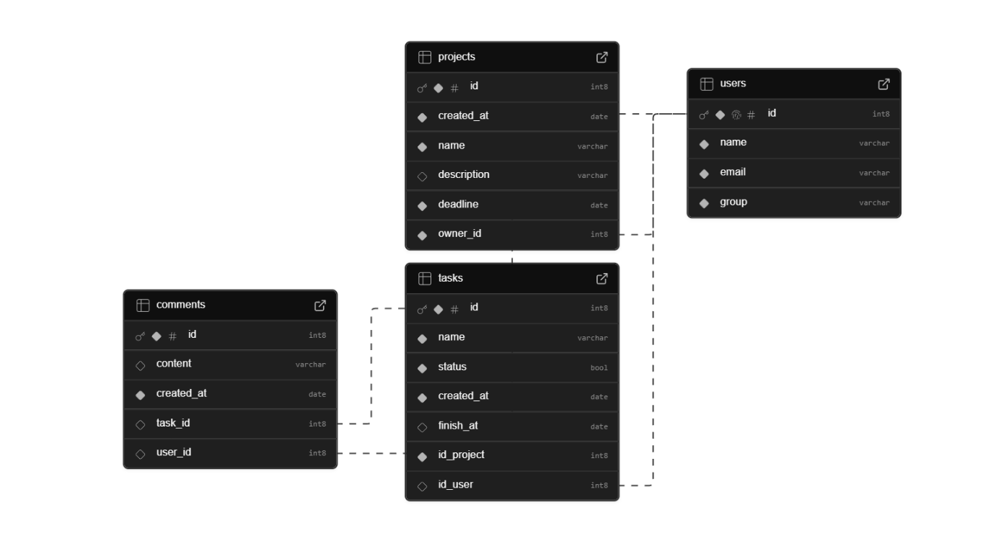
4. Architecture
The system follows layered architecture with separation of concerns.

UI Layer
Interaction layer for user and program interaction:
- Main

Domain Logic
Represents the core of the system and contains business rules:
- Entities representing domain objects
- Service classes implementing business logic
- Design patterns such as Factory and Builder
- Domain-specific exceptions

Data Access Layer
Handles persistence and database communication:
- Repositeries interfaces
- Repositeries implementations

Infrastructure Layer
Provides technical services such as database connection management and error handling related to system operations.
- DB pool
- DB connection
- Technical exception

Shared/Utility layer
Contains reusable helper classes used across multiple components.
- Utilities
5. Language Features and Design Patterns

Generics
Generics are used for collections and filtering tasks.
Example:
- List<Task>
- TaskFilter<T>
This allows flexible and reusable filtering logic.

Singleton Pattern
The Singleton pattern is used in Connection Pooling to to handle multiple reqests and reduce connection time.

Builder Pattern
The Builder pattern is used to create complex Project objects.

Factory Pattern
The Factory pattern is used to create different task types:
- BugTask
- FeatureTask
- ResearchTask
This improves scalability and simplifies object creation.
6. Components and Component Principles

Component Description
The system is divided into domain-based components that group classes based on reuse, maintenance, and dependency relationships.

User Component
Classes
- User
- IUserRepository
- UserRepository
- UserService
- DuplicateEmailException
- UserNotFoundException
REP
User-related classes are reused together and released as a single module.
CCP
User entity, repository, and service change together when user management logic changes.
CRP
Other components depend only on user functionality they require through service interfaces.

Task Component
Classes
- Task
- BugTask
- FeatureTask
- ResearchTask
- TaskFactory
- TaskService
- ITaskRepository
- TaskRepository
- Task-related exceptions
REP
Task creation, management, and validation are always reused together.
CCP
Task business rules change together (status updates, deadlines, types).
CRP
Other modules depend only on task service abstraction.

Project Component
Classes
- Project
- ProjectBuilder
- ProjectService
- IProjectRepository
- ProjectRepository
- Project exceptions
REP
Project creation and management classes are reused together.
CCP
Project structure changes affect all project-related classes simultaneously.
CRP
External modules interact only through service interfaces.

Comment Component
Classes
- Comment
- CommentService
- ICommentRepository
- CommentRepository
REP
Comment functionality is always reused as a unit.
CCP
Comment logic changes are isolated inside this component.
CRP
Components use comment services without depending on repository implementation.

Infrastructure Component
Classes
- SuperbaseDB
- IDBPool
- DatabaseOperationException
REP
All database technical functionality is reused together.
CCP
Database connection changes affect only infrastructure classes.
CRP
Domain components depend only on repository interfaces.

Shared Component
Classes
- IRepository
- EntityFilter
REP
Reusable abstractions are grouped for common reuse.
CCP
Utility and abstraction changes affect all components consistently.
CRP
Only reusable abstractions are exposed to other components.

7. Exception Handling
The system handles several error situations:
- Invalid task status transition
- Creating task without project
- Setting deadline in the past
8. SOLID Principles
The system follows SOLID principles:
- Single Responsibility Principle – Each service handles one type of logic
- Open/Closed Principle – New task types can be added without modifying existing code
- Liskov Substitution Princple – Classed derived from Task can be used in context of their parent without brokeing logic
- Interface Segregation Principle – Each interface reqire method relevant only for its implementations
- Dependency Inversion Principle – Classes depends on interfaces rather than implementation
9. Conclusion
The Student Task & Project Management Tool demonstrates key object-oriented programming concepts, design patterns, and component design principles. The project improves task management and collaboration between users while maintaining scalable and maintainable architecture.

